We demonstrate how to use KidsBlock on Windows system

- Interface
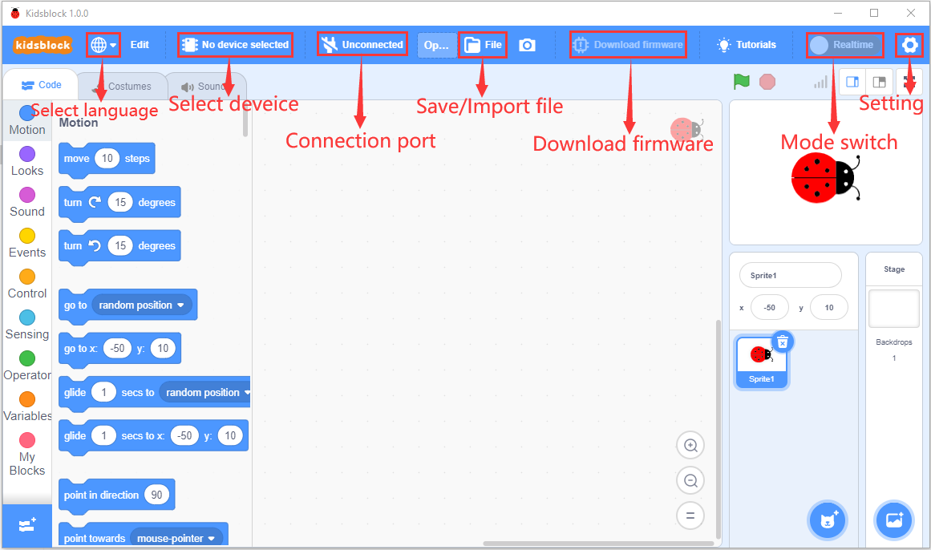
- Clickto switch to different languages
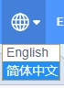
3. Clickto select“Install driver”.
Note: if the driver should be installed, as shown below;
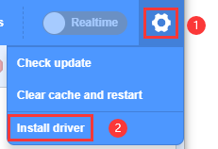
- Click “Next” at the Device Driver Installation Wizard page.
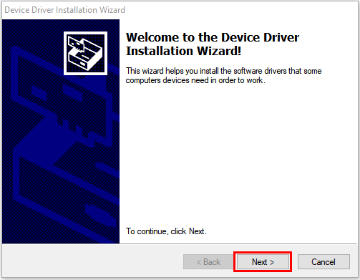
- After a while, click“Finish”
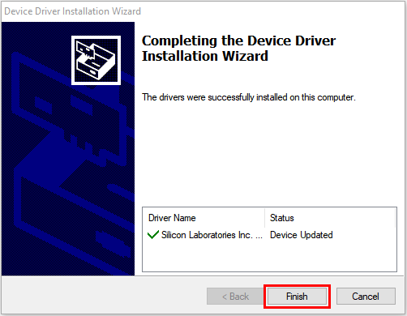
- Then click“Next”.

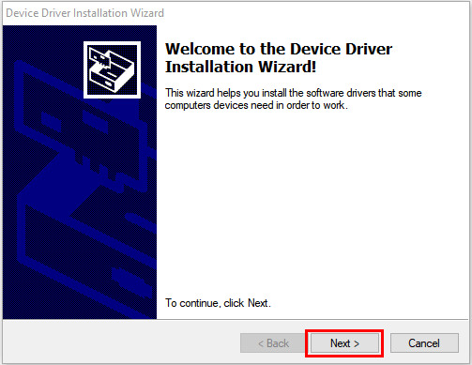

- And click“Finish”.

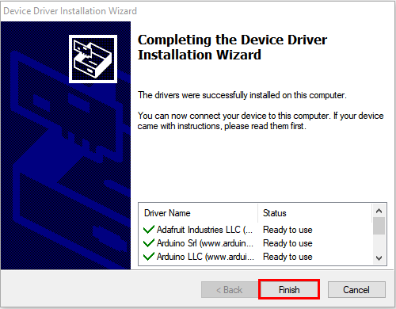
- Then click“Install”

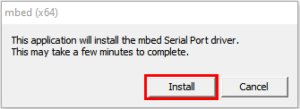
- After a while，click“Finish”
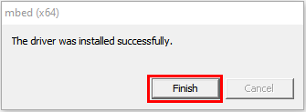
- Select“Extract”
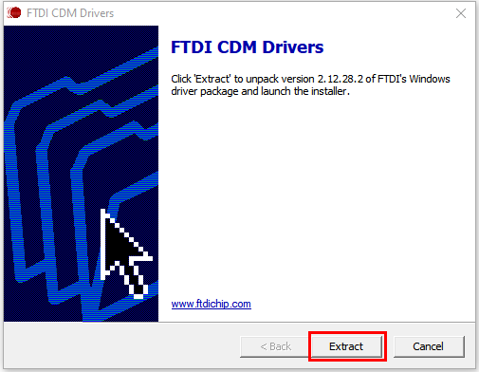
- Click“Next”
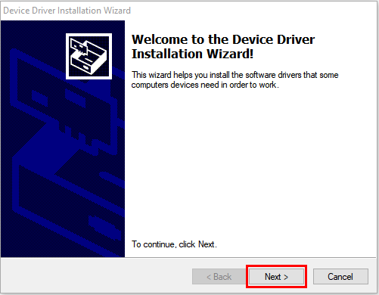
- Next, click“I accept this agreement”and“Next”。
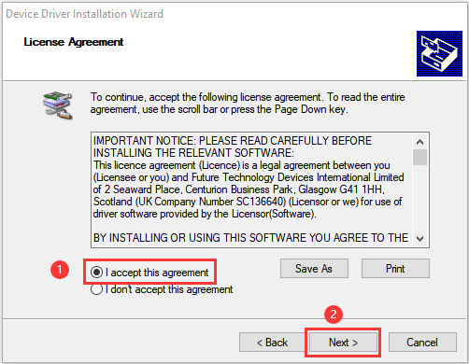
- Click“Finish”.
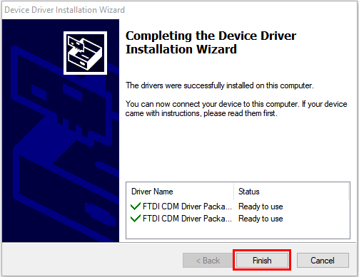
- After a while, click“INSTALL”
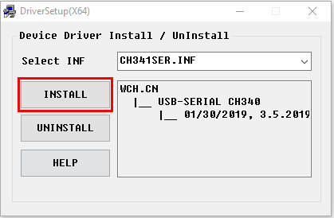
- After a few seconds, when the driver is installed, just click“OK”
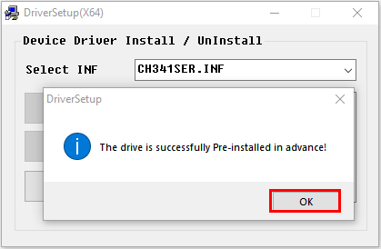

Click to enter the main page, select the control board needed. In this project, we select the Plus board and click Connect.
Then it is connected,
Click Go to Editor to return the code editor.
Icon will change into and will change into . This means the Plus board is connected to the COM port.
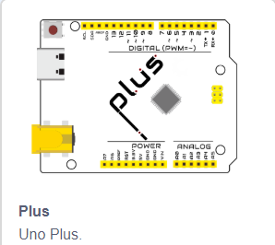

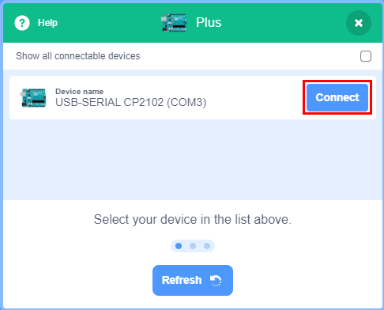

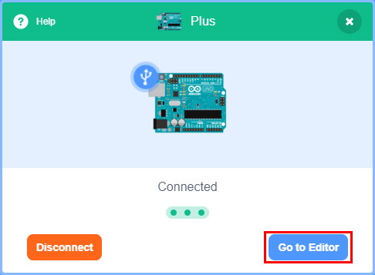

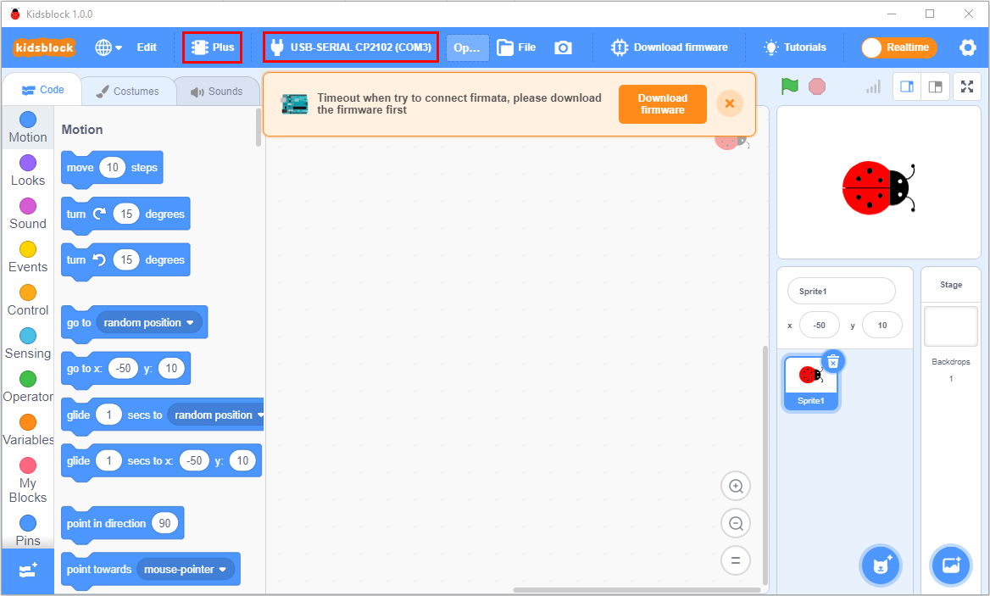
If the ESP8266 board is connected , but icon doesn’t change into . You need to click to connect the COM port.
Click and Connect.
Then you will find a page pop up, showing Connected
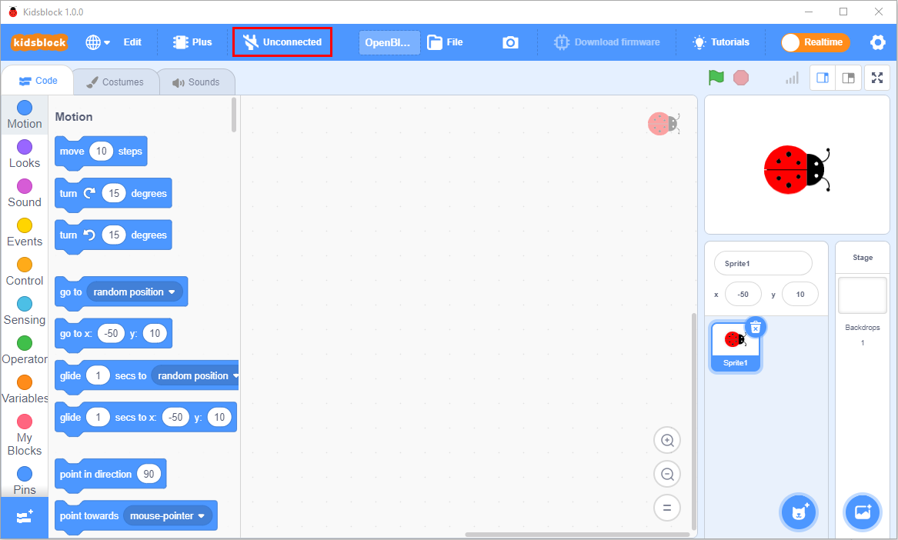

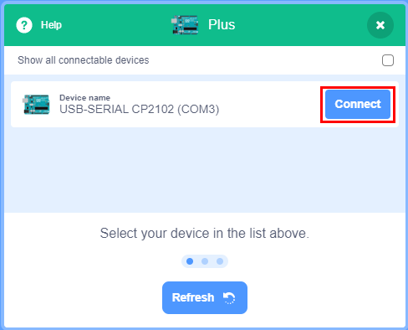

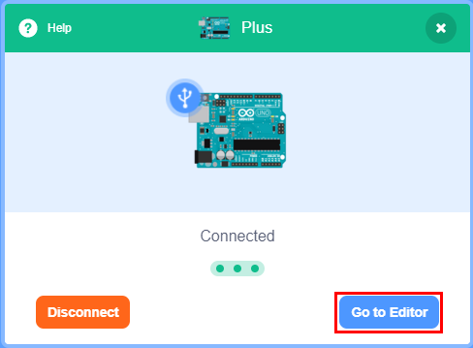


To disconnect the port, just click and Disconnect
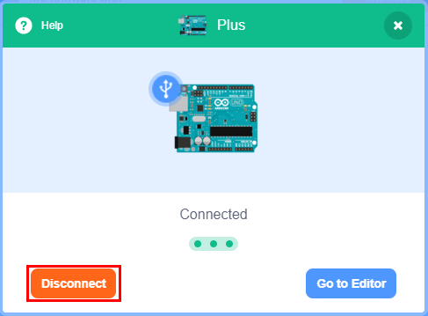
The Plus board and the COM port are connected, then click to switch modes. Then will change into
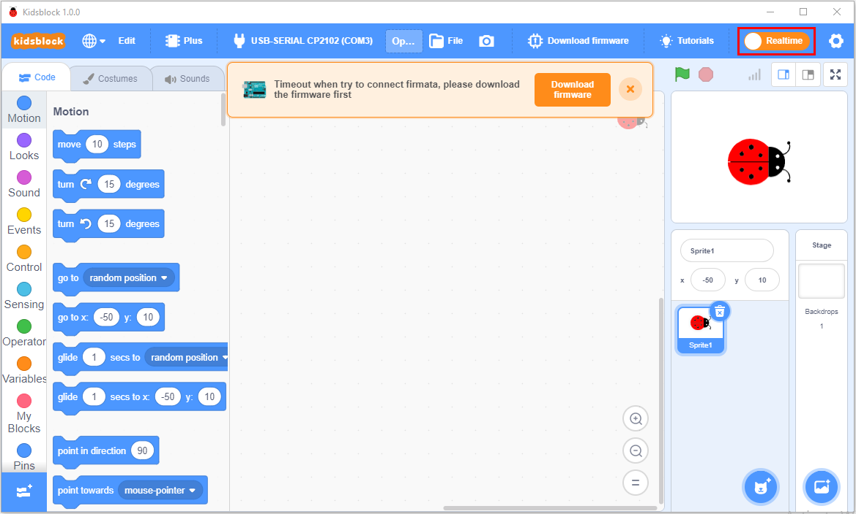
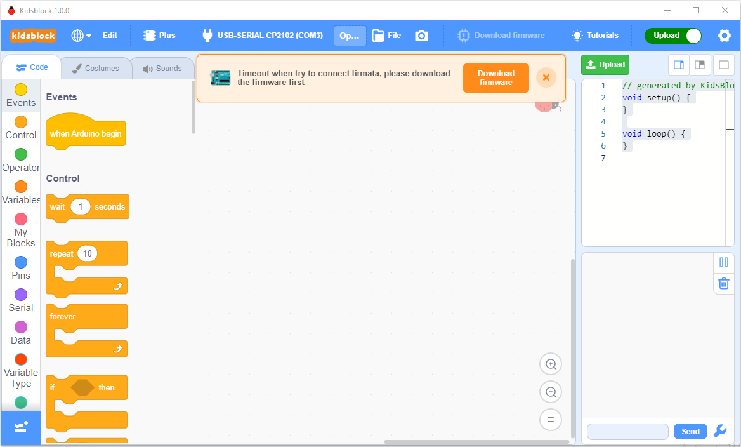
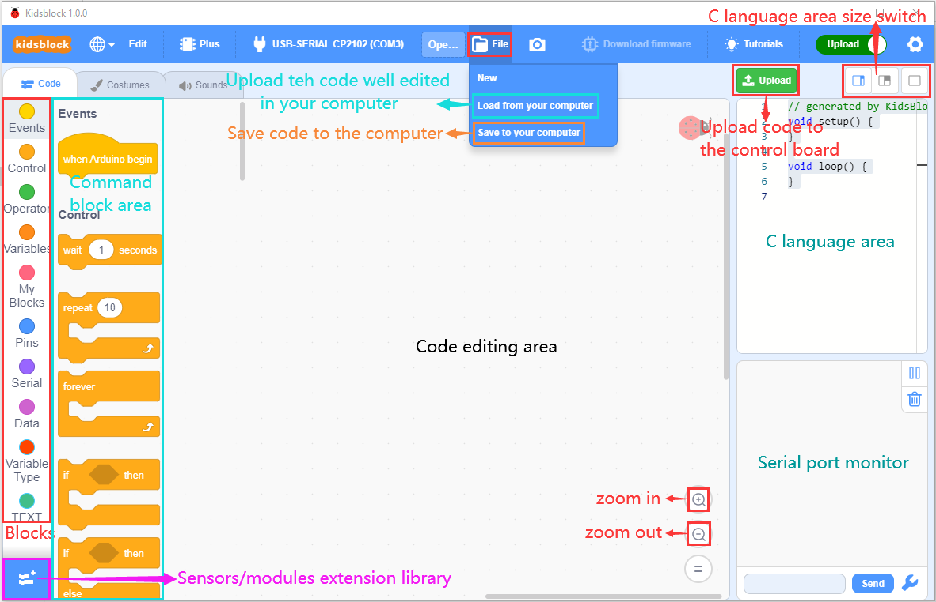

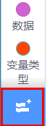stands for extension libraries of sensors and modules.
Click  to enter the page of extension libraries, click a sensor or module to add.
For example, if click the“passive buzzer”,“Not loaded”will change into“Loaded”. Then the passive buzzer is added
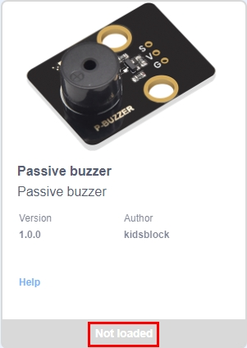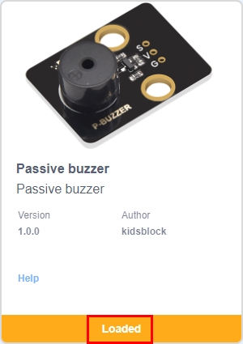
Click to return the code editor. Then you can view the passive buzzer in the blocks area.
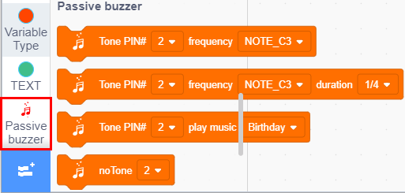
If you want to delete the passive buzzer, click  to select the passive buzzer. Then“Loaded”will change into“Not loaded”.
Then the passive buzzer is deleted.
。 

- How to open SB3 type files：

1：Double-click SB3 type files to open them.

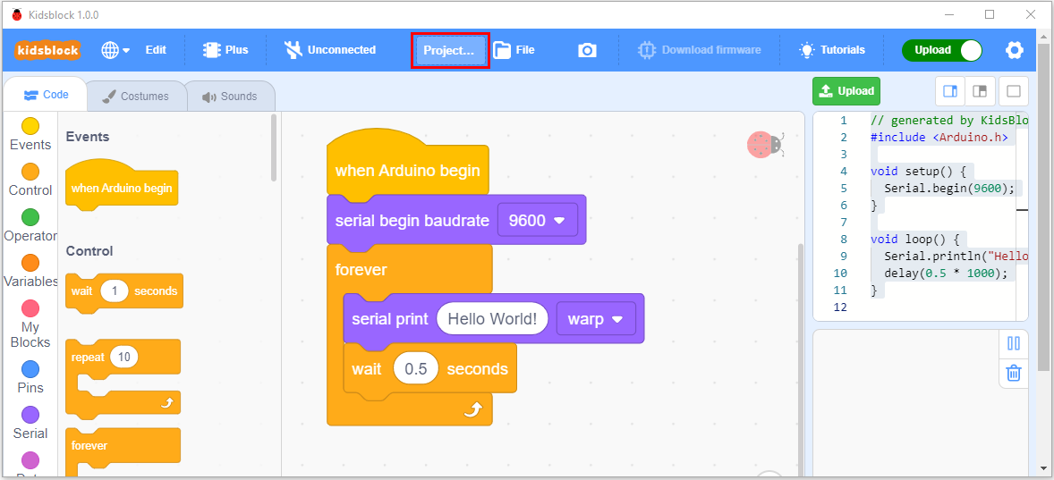
- Open Kidsblock，click file and Load from your computer，then select the SB3 type file on the computer.（for example ）

